DW binary systems

Sources:
PanStar-1 image access, https://ps1images.stsci.edu/cgi-bin/ps1cutouts?pos=18%3A32%3A36.539+++20%3A31%3A08.202&filter=color&filter=g&filter=r&filter=i&filter=z&filter=y&filetypes=stack&auxiliary=data&size=240&output_size=0&verbose=0&autoscale=99.500000&catlist= :
- Got the images and most of the description from the far right image that was loaded when inputting the RA and Dec of the stars Manuel gave me
https://aladin.cds.unistra.fr/AladinLite/
- Got some of the extra data such as the Gaia and Simba info and also got the photo for J0338-8139
https://simbad.cds.unistra.fr/simbad/sim-basic?Ident=23%3A22%3A30.203++++5%3A09%3A42.058&submit=SIMBAD+search

Seemly good candidates 🤔: J2322+0509, J0935+4411(very bright), J0634+3803(maybe), J1526-2711(also maybe), J1506-1125, J1235+1543(kind of looks like it’s in the void), J0056-0611(some friend with it but seems good distance), J0923+3028(has some buddies), J1436+5010(some bright star right on the edge)

Name Gmag Gmag_e ra dec

J2322+0509 18.7466 0.0020 23:22:30.203 5:09:42.058
- Doesn't have too many other sources, maybe some really dim star near by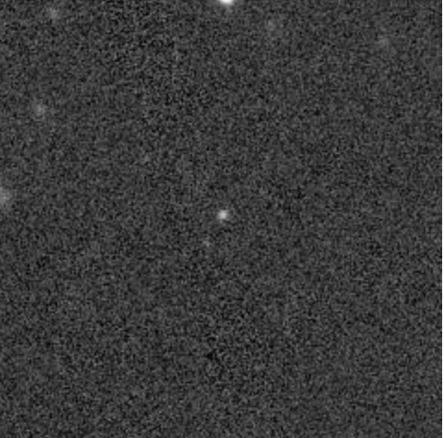
- Info from Aladin
  - Gaia DR3 26607734, PM:13.667 (from Aladdin website where i can click on the little circle and it tells me the Gaia data if Gaia is selected)
  - Gaia RA and DEC: 350.62584588574 5.16168267182
  - Main ID from Simbad catalog: PB 5353, PM: pmra11.758 pmdec-6.965
  - Sinbad RA and Dec: 350.6257934130 +5.1617136283
- Simbad Coord website
  - ID PB 5353
  - PM: 11.758 -6.965

J0935+4411 17.8045 0.0062 9:35:06.897 44:11:06.919
- Doesn’t have really any stars near by
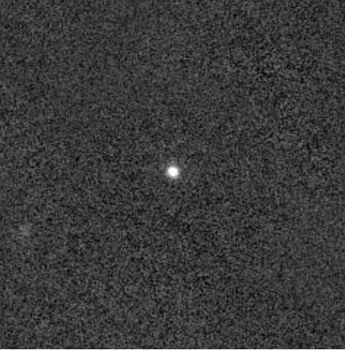
- Info from Aladin
- Gaia DR3 81509298, PM:20.351
- Gaia RA and DEC: 143.77873662778 44.18525527397
- Main ID from Simbad catalog: US 738, PM: pmra-20.315 pmdec-1.213
- Sinbad RA and Dec: 143.7788625382 +44.1852606652
- Simbad Coord website
  - ID: US 738
  - PM: -20.315 -1.213

J1239-2041 18.9418 0.0019 12:39:50.370 -20:41:42.276
- In between two other stars and a third star above it (so 4 total sources in a 60 parsecs pixel)
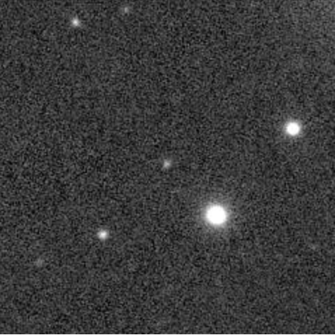
- Info from Aladin
- Gaia DR3 350361328, PM:11.904
- Gaia RA and DEC: 189.95987569252 -20.69507653573
- Main ID from Simbad catalog: GALEX J123950.2-2 PM: pmra-9.039 pmdec7.746
- Sinbad RA and Dec: 189.9599186377 -20.6951109628
- Simbad Coord website
  - ID: GALEX J123950.2-2
  - PM: -9.039 7.746

J0634+3803 17.1331 0.0011 6:34:49.904 38:03:51.975
- One big ball of light in the corner of the square and the many target looks to be significantly dimmer than the big ball of light
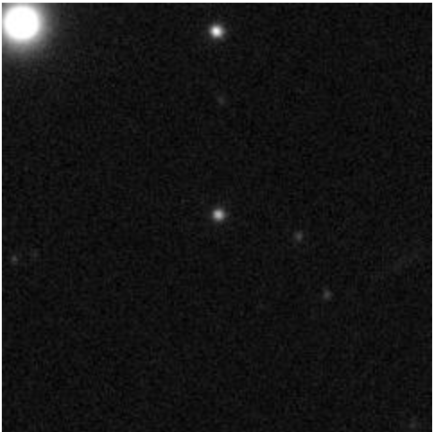
- Info from Aladin
- Gaia DR3 943429565, PM:37.951
- Gaia RA and DEC: 98.70793535266 38.06443759899
- Main ID from Simbad catalog: SDSS J063449.92+3, PM: pmra-23.590 pmdec-29.729
- Sinbad RA and Dec: 98.7080685180 +38.0645697262
- Simbad Coord website
  - ID: SDSS J063449.92+3
  - PM: -23.590 -29.729

J1946-1318 17.4439 0.0015 19:46:12.798 -13:18:22.786
- A lot of different stars
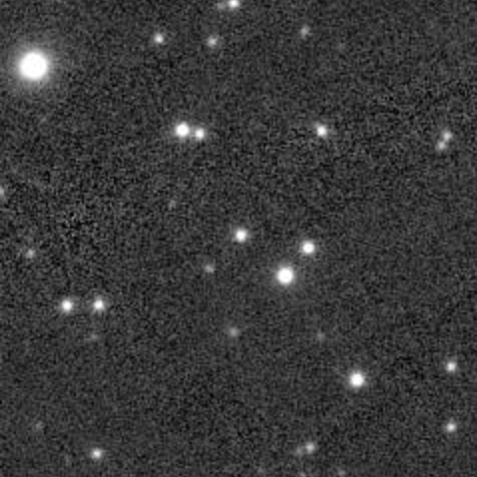
- Info from Aladin
- Gaia DR3 418346750, PM:4.679
- Gaia RA and Dec: 296.55332409174 -13.30632954976
- Main ID from Simbad catalog: GALEX J194612.7-1, PM: pmra4.619 pmdec0.744
- Sinbad RA and Dec: 296.5533029970 -13.3063328585
- Simbad Coord website
  - ID: GALEX J194612.7-1
  - PM: 4.619 0.744

J0338-8139 17.2902 0.0011 3:38:16.193 -81:39:29.967
- The PanSTARRS 3PI survey images cover the sky north of declination -30 deg.
- No result cant see withe PanStar tool
- Due to me for getting which thing to set aladdin to i dont know if its and image in the same wavelength as the rest
- However there is a small star right next to it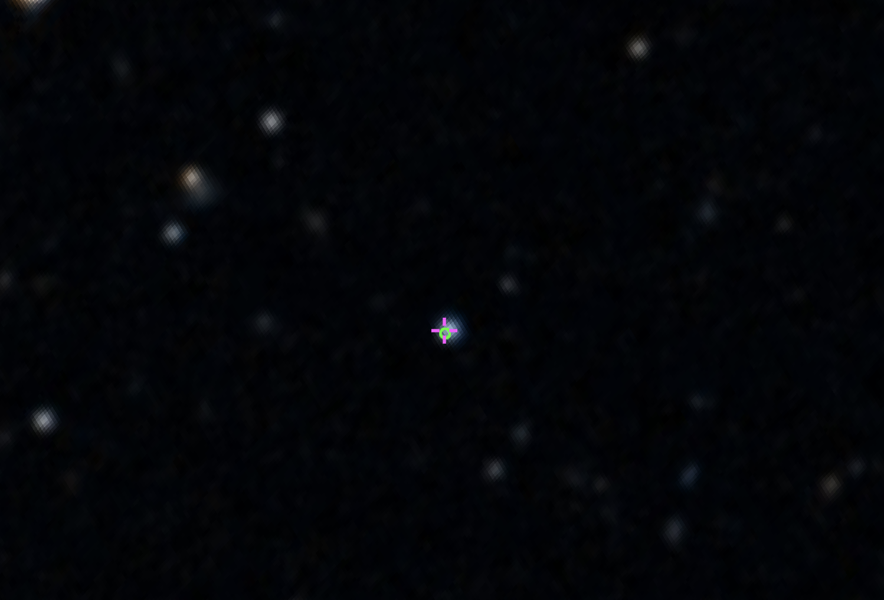
- Info from Aladin
  - Gaia DR3 46190741 PM:14.180, pmra13.029 pmdec5.596
  - Gaia RA and DEC: 54.56746987594 -81.65832415289
  - Main ID from Simbad catalog: GALEX J033815.9-8, PM: pmra13.029 pmdec5.596
  - Sinbad RA and Dec: 54.5670707387 -81.6583490236
- Simbad Coord website
  - ID: GALEX J033815.9-8
  - PM: 4.619 0.744

J1526-2711 18.3489 0.0020 15:26:01.115 -27:11:56.660
- Two little big balls of light in the corner
- Some dimmer stars close to it
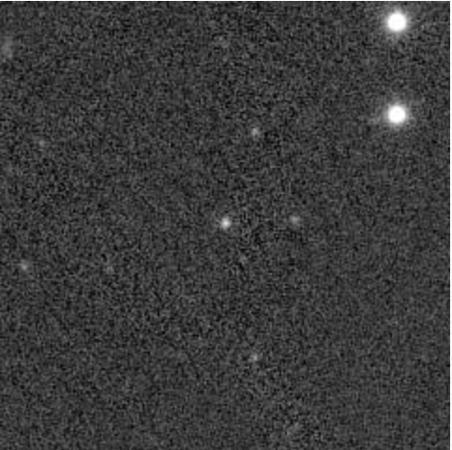
- Info from Aladin
- Gaia DR3 62136199, PM:3.482
- Gaia RA and DEC: 231.50464756546 -27.19907220393
- Main ID from Simbad catalog: PSO J231.5046-27, PM: pmra2.668 pmd-2.237
- Sinbad RA and Dec: 231.5046342310 -27.1990622622
- Simbad Coord website
  - ID: PSO J231.5046-27
  - PM: 2.668 -2.237

J2049+3351 18.7010 0.0024 20:49:51.274 33:51:53.126
- More stars close to it
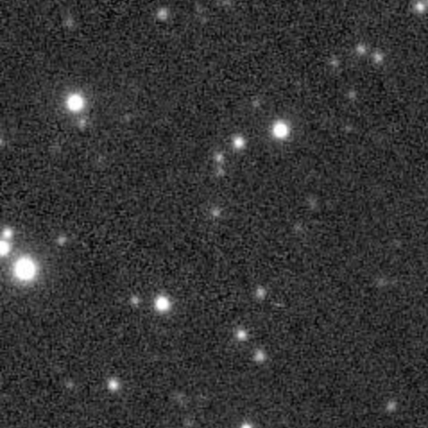
- Info from Aladin
- Gaia DR3 18691112, PM:2.221
- Gaia RA and DEC: 312.46364358406 33.86475720324
- Main ID from Simbad catalog: PSO J312.4636+33 PM: pmra-0.446 pmdec-2.176
- Sinbad RA and Dec: 312.4636459725 +33.8647668731
- Simbad Coord website
  - ID: J312.4636+33
  - PM: -0.446 -2.176

J1506-1125 17.0104 0.0015 15:06:12.345 -11:25:11.994
- One main star with a few little spots that seems to show in this wavelength with a small pair below and one above
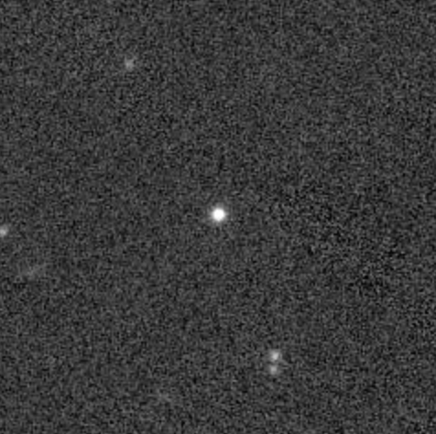
- Info from Aladin
- Gaia DR3 63128379, PM:10.720
- Gaia RA and DEC: 226.55143810657 -11.41999826588
- Main ID from Simbad catalog: GALEX J150612.3-1, PM: pmra0.419 pmdec-10.712
- Sinbad RA and Dec: 226.5514362082 -11.4199506579
- Simbad Coord website
  - ID: GALEX J150612.3-1
  - PM: 0.419 -10.712

J1235+1543 17.5162 0.0012 12:35:49.853 15:43:18.954
- Single source
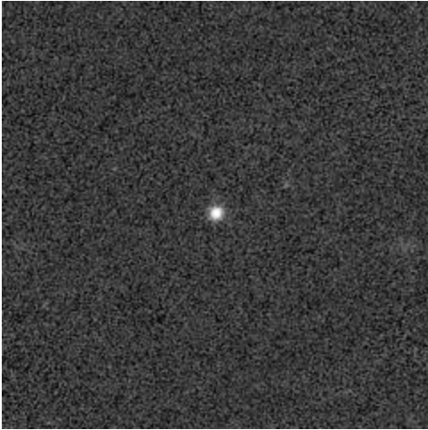
- Info from Aladin
- Gaia DR3 39335578, PM:41.310
- Gaia RA and DEC: 188.95771890669 15.72193179104
- Main ID from Simbad catalog: A3 476 PM: pmra-32.511 pmdec-25.486
- Sinbad RA and Dec: 188.9578690150 +15.7220450636
- Simbad Coord website
  - ID: A3 476
  - PM: -32.511 -25.486

J0056-0611 17.5441 0.0010 0:56:48.240 -6:11:41.804
- Just a single other star near by
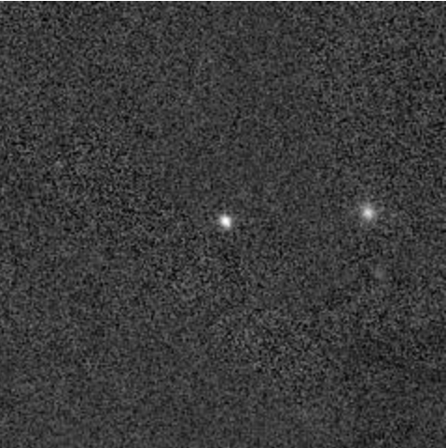
- Info from Aladin
- Gaia DR3 25243900, PM:22.733
- Gaia RA and DEC: 14.20099900190 -6.19494550092
- Main ID from Simbad catalog: GALEX J005648.1-0 PM: pmra16.746 pmdec-15.374
- Sinbad RA and Dec: 14.2009241372 -6.1948771727
- Simbad Coord website
  - ID: GALEX J005648.1-0
  - PM: 16.746 -15.374

J0923+3028 15.9203 0.0008 9:23:45.598 30:28:04.609
- 3 other stars in the image
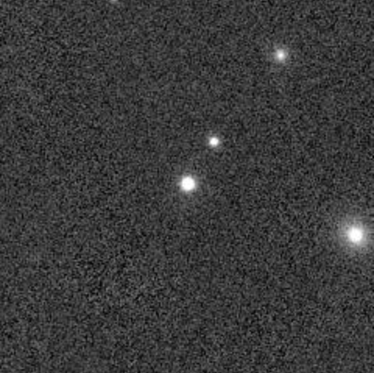
- Info from Aladin
  - Gaia DR3 70034692, PM:29.885
  - Gaia RA and DEC: 140.93999002815 30.46794693363
  - Main ID from Simbad catalog: CBS 6, PM: pmra-3.797 pmdec-29.642
  - Sinbad RA and Dec: 140.9400096070 +30.4680786779
- Simbad Coord website
  - ID: CBS 6
  - PM: -3.797 -29.642

J1436+5010 18.4158 0.0014 14:36:33.303 50:10:26.843
- One big star on the edge of the image and it seems a small spot is a little brighter to the right of the star
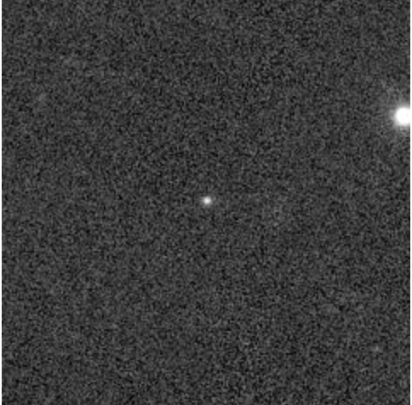
- Info from Aladin
  - Gaia DR3 16035547, PM:9.983
  - Gaia RA and DEC: 219.13876457169 50.17412295411
  - Main ID from Simbad catalog: SBSS 1434+503, PM: pmra8.558 pmdec-5.140
  - Sinbad RA and Dec: 219.1387051814 +50.1741457967
- Simbad Coord website
  - ID: SBSS 1434+503
  - PM: 8.558 -5.140

J1832+2031 17.6301 0.0007 18:32:36.539 20:31:08.202
- A lot of other stars in the image
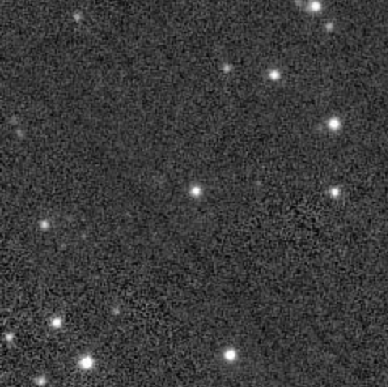
- Info from Aladin
- Gaia DR3 45258721, PM:8.123
- Gaia RA and DEC: 278.15224762656 20.51894493645
- Main ID from Simbad catalog: SDSS J183236.53+2, PM: pmra8.116 pmdec-0.329
- Sinbad RA and Dec: 278.1522091122 +20.5189463972
- Simbad Coord website
  - ID: SDSS J183236.53+2
  - PM: 8.116 -0.329

